(Approx. 253 words)

System Monitoring Tools
Author: Frank Fota, Newsletter Editor, Fredericksburg PCUG, MD
November 2019 issue, FPCUG Notes
www.fpcug.org
Fotafm (at) gmail.com

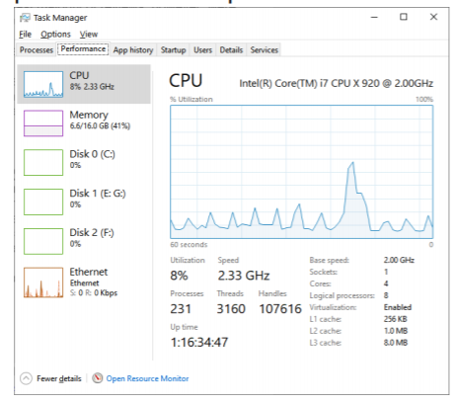
Have you ever wanted to view the impact a program has on your computer’s performance? A quick internet search reveals that there are other many monitoring tools available. Some are freeware and others require payment. Resource monitoring tools are also bundled with system utilities (e.g., Norton Utilities®). Microsoft Windows has a “Resource Monitor” that can be run from a Command Prompt or via the search box by typing, “perfmon.exe.” Windows Resource Monitor is extensive but, difficult to configure. A quick look at resources can be found, however, by opening the Windows Task Manager (i.e., Ctrl-Alt-Del then click on Task Manager). Click on the Performance tab in Windows Task Manager and it’s easy to see the effect that a program has on CPU, Memory, Disk, or Network performance.

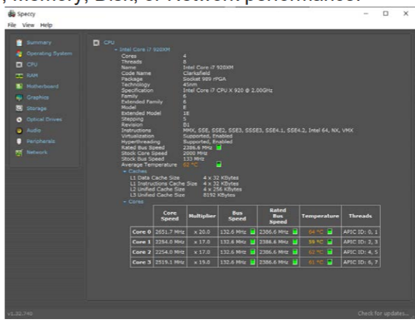
If you need more details about the hardware on your PC (e.g., the effect a program has on CPU or GPU core temperatures), I recommend Speccy®. Speccy® is written and published by Piriform (now owned by Avast); the same company that developed CCleaner®. According to Jeffrey Wilson, Lead Analyst for PC Magazine, “This utility serves up a wealth of data about your PC's operating system, attached peripherals, memory, storage, and much more.”

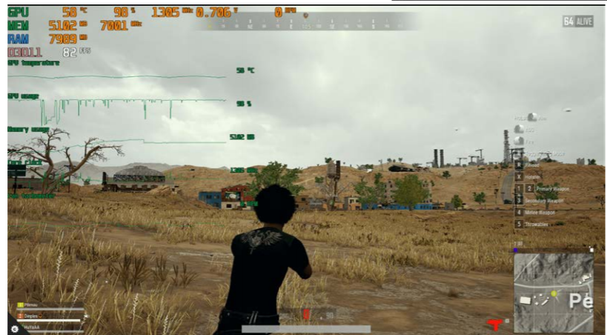If you are looking for a program that will overlay hardware statistics on top of a running game, you can install MSI’s Afterburner program. It’s compatible with both Nvidia and AMD’s Radeon graphics cards.

